Reading: Name of- class reader: Journey to the River Sea  Reading:  Skills taught prediction, summarising, inference and questioning.  The children will:  • Discuss characters and events  • Recognise and read common exception words for Year  5/6.  • Use phonic knowledge to read words  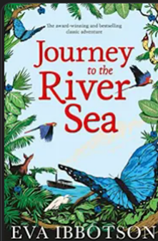  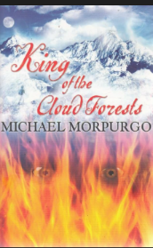  Year 5 Home Reader: | Writing:  Fiction:  Summer 1 term - Narrative and poetry: The children will be studying part of ‘The Tempest’ by William Shakespeare and writing diary entries focusing on the use of figurative language in a poem.  Summer 2 term – Journey to the River Sea. The children will be writing in role  The children will be focusing on recapping their spelling, punctuation, and grammar from Year 4, and using this effectively in their writing. As well as the basics, we will focus on using figurative language and a variety of sentence starters and expanded noun phrases.  Non-Fiction:  Summer 1 term – Use a range of model texts the children will write an autobiography about a person from history.  Summer 2 term – Journey to the River Sea. The children will be writing a playscript of an interview.  We will focus on:  • Building cohesion within and across paragraphs  • Creating atmosphere in narrative  • Using non-standard English in writing dialogue  • Similes, Metaphors, Personification, Alliteration and Onomatopoeia  • Sub-Ordinate Clauses | Religious Education  The theme is    Summer 1 term – Christianity: Gospel - What would Jesus do?  Summer 2 term – Christianity: People of God – How can following God bring freedom and justice?   | Mathematics:  In mathematics for this term, we will be looking at ‘Decimals and Percentages’, ‘Perimeter and Area’ and ‘Shape’.  This will include:  • Equivalent fractions and decimals  • Thousandths as fractions and decimals  • Order and compare decimals  • Perimeter of rectangles and polygons  • Area of rectangles and compound shapes  • Understanding and using degrees  • Classifying and estimating angles  • Calculate angles around a point and on a straight line.  • Regular and irregular polygons  • 3D shapes
Computing:  Kapow Scheme of Work-  We will focus on:  • Online safety and reputation  • To design a functional Mars Rover to travel on Mars, using the programme ‘Tinkercad’. |  | Personal, Social and Emotional development:  Using the Jigsaw scheme the unit we will study is:  Summer 1 term – Relationships  Summer 2 term – Changing Me
Geography:  Summer 1 – What is life like in the Alps?  We will focus on:  • Where are the Alps? What is it like in the Alps?  • Why do people visit the Alps?  • What is there to do in our local area?  • How are the Alps different from our local area?  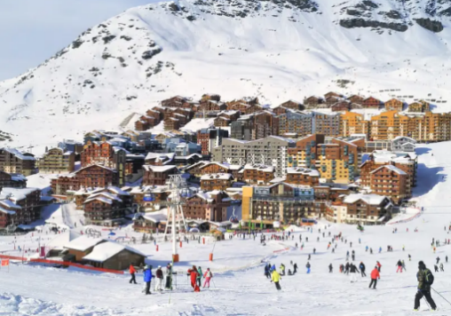  History:  Summer 2 term – What did the Greeks ever do for us?  We will focus on:  • Who were the Ancient Greeks and when did they live?  • Who lived on Mount Olympus?  • How was ancient Greece governed?  • Did the ancient Greeks give us democracy?  • How do the ancient Greek philosophers influence us today?  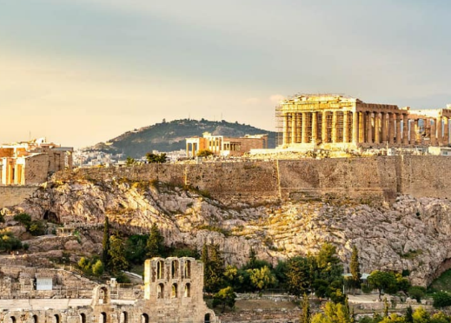 | Links to Spirituality  WOWS: Representing the festival of Holi through musical composition.  Developing and cooking a recipe  OWS: To learn about the challenges of living in the Alps.  NOWS: How to be safe as part of an online community, staying safe and happy online.  Looking at the changes we go through as we develop and grow. | Foreign language:    Spanish  Summer 1 term:  - Days/Months of the year.  - Directions  - Names of rooms in the house  Summer 2 term:  - Body parts  - Clothes  - Colours  Conversation revision | Music  This is taught through the Kapow music scheme.  Summer 1 term – Composition to represent the festival of colour (Theme: Holi festival)    Summer 2 term – Looping and remixing  
 | Art:  Through Kapow  Summer 1 - Craft and design: Architecture  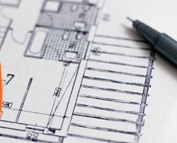  We will focus on:  • Observational drawing - houses  • House monoprint  • Be an architect  • Friedensreich Hundertwasser  • Monument |  | DT:  Through Kapow  Summer 2 – Cooking and nutrition: Developing a recipe  We will focus on:  • From farm to fork  • Different choices  • Nutritional value  • Preparing ingredients  • Designing labels  • Making bolognese  