



Religious Education Policy

June 2025
Review date: June 2028

‘I can do all things through the one who strengthens me.’
Philippians 4.13

Our desire is that the strong Christian foundation children receive at St Margaret’s School will give them the confidence to explore the world around them with awe and wonder. We want to build a whole community based on the values of faith, hope and love. We strive for excellence aiming to develop children who are happy, intrinsically motivated, resilient and independent and who believe there is nothing they cannot achieve.

The legal position of RE in our school including syllabus taught.

St. Margaret’s is a Church of England School and therefore the provision of RE is in accordance with the Trust Deed of the School and incorporates the statement of entitlement for Religious Education in Church of England Schools:
https://www.churchofengland.org/sites/default/files/2019-02/re-statement-of-entitlement-for-church-schools.pdf
The Governors, in consultation with the head teacher, and following advice from the Diocese have decided to make Understanding Christianity the main scheme and to supplement this with material from the Locally Agreed Syllabus for Solihull alongside using the Emmanuel Project for exploring and understanding other faiths and religions. This approach allows us to provide a deep understanding of Christianity in line with our Christian vision, while ensuring that our students gain knowledge of the six major world religions. This inclusive approach reflects and represents the diverse beliefs in our community.

School Aims
Our curriculum design is expected to lead to the following outcomes for children leaving our school:
- Children enjoy learning, being keen to explore and express, to discuss and discover, to question and to wonder;
- Children are happy, confident individuals who understand mistakes are good, being able to learn from them and overcome failure;
- Children develop socially and morally, understanding how society holds together through exploring themes such as sustainability and diversity and are able to become contributing citizens;
- Children develop personally to be emotionally and physically heathy, understanding risk and how to be safe;
- Children understand the part that theirs and other people’s beliefs play in their lives;
- Children achieve well, meeting and exceeding national expectations and/ or personalised goals;
- Children make at least expected progress from their starting points with the aim for many to be good or better;
- Children’s behaviour is good or better;
- School attendance is better than average for primary schools.
School Values

The teaching of Religious Education is set in the context of our core Christian values each of which has a secure root in biblical teaching. We have identified three core values that we believe are central to the work of our educational community. "And now these three remain: faith, hope and love. But the greatest of these is love.". (1 Corinthians 13:13) None of these values can be lived out in isolation with love being the most important of all of these.

- Faith is the cornerstone of this foundation and the motivation of those who provide this education. It is through faith that our community learns to trust in God's promises, believing that He is their refuge and strength, an ever-present help in times of trouble (Psalm 46:1). Faith empowers our community to step forward with confidence, knowing that their abilities are magnified by His power.
- Hope is the anchor that keeps children and adults alike steadfast. In moments of uncertainty and adversity, hope reminds them that God's plans for them are good, to give them a future and a hope (Jeremiah 29:11). This hope is not wishful thinking, but a confident expectation rooted in God's unchanging nature and His faithfulness.
- Love is the greatest of these virtues, as it binds everything together in perfect harmony (Colossians 3:14). Experiencing love compels our school community to act, to serve, and to persevere. It is through this love that they find the strength to overcome challenges, to forgive, and to extend love and grace to others.

Aims for teaching RE

As a church school, the aims of Religious Education at St. Margaret’s School are:
- to enable pupils to encounter Christianity as a living faith that influences the lives of people worldwide and as the religion that has most shaped British culture and heritage
- to enable pupils to talk about core theological concepts such as God, Creation, Salvation, the Kingdom of God, The People of God, Incarnation, The Fall, Gospel and explain why they are important to Christians
- to enable pupils to recognise diversity and learn about major world religions (and world views), their impact on society, culture and the wider world, facilitating pupils’ expression of responses and insights
- to contribute to the development of pupils’ own spiritual / philosophical convictions, exploring and enriching their own faith and beliefs
- to enable pupils to respect the faith of others, and value the journey of faith
- to ensure that pupils can speak comfortably and confidently about their understandings of faith and life choices.
- to enable pupils to appreciate the way in which religious beliefs can shape personal and social life and contribute to personal morality and social responsibility
- to enable pupils to develop knowledge and skills in making sense of biblical texts and the Christian narrative and understanding their impact in the lives of Christians
- to develop pupils’ abilities to connect, critically reflect upon, evaluate and apply their learning to their own growing understanding of Christianity, of religion and belief more widely, of themselves, the world and human experience.

Drawn from the Solihull Agreed Syllabus (2017). The outcomes from The Church of England Education Office’s ‘Religious Education in Church of England Schools - A Statement of Entitlement’ (2019) and Understanding Christianity.

The distinctive contribution RE makes to the life of the school and the community and other curriculum aims

As a church school we are committed to finding ways to contribute to every pupil having a life enhancing encounter with the Christian faith and with the person of Jesus Christ. At St. Margaret’s School, this means that we will endeavour to ensure that encounters with the Christian faith will be positive for the pupils and that they will hear of the story of Jesus. Such encounters will show the pupils to the treasures of the Christian faith in a way that invites, but does not coerce. The values and character of the school will also be shown in the way that attention is paid to the teaching of world faiths particularly those represented in the school community and local neighbourhood.
RE subject matter gives particular opportunities to promote an ethos of respect for others, challenge stereotypes and build understanding of other cultures and beliefs. This contributes to promoting a positive and inclusive school ethos that champions democratic values and human rights. RE is taught in the context of our whole school philosophy of teaching and learning which promotes enquiry, questioning, debate, collaboration, struggle, retrieval and reflection.

Spiritual, moral, social and cultural development
Learning about and from religious traditions helps pupils to appreciate which aspects of life have been significant for most of humanity throughout the ages. Exploring the concepts of religion and belief and their roles in the spiritual, moral and cultural lives of people in a diverse society helps individuals develop moral awareness and social understanding. It also helps to show them what shapes people’s behaviour and motivations, and points pupils towards positive models for their own lives. RE lessons particularly include opportunities for pupils to develop spiritually - helping them to recognise and deepen their relationships with self, others, the planet and, for many, with God. In addition, when appropriate RE lessons offer spiritual moments for stillness, reflection and response.

Personal development and well-being
RE plays an important role in preparing pupils for adult life, employment and lifelong learning. It helps children and young people become successful learners, confident individuals and responsible citizens. It gives them the knowledge, skills and understanding to discern and value truth and goodness, strengthening their capacity for making moral judgements and for evaluating different types of commitment to make positive and healthy choices.

Approaches to teaching RE.
High quality learning experiences in RE are designed and provided by careful planning using Understanding Christianity, The Solihull Agreed Syllabus and the Emmanuel Project and seeking diocesan advice, taking into account the need to offer breadth of content.

- In order to make religious education a lively, active subject we employ a variety of teaching methods including art, music, discussion, debate, the development of thinking skills, drama, the use of artefacts, pictures, stories, and the use of periods of stillness and reflection. We have opportunities for classes to visit places of worship, as well as arranging visits from members of local faith communities. We use a variety of approaches of helping pupils to appreciate, and to begin to develop critical thinking about, religious life and teachings, including enquiry based and philosophical approaches. We ensure that topics and themes are revisited across the year groups in line with our teaching and learning policy.

Religious Education at St. Margaret’s school is taught in the following way.
We use as a basis for our planning the Understanding Christianity Scheme of Work, alongside the Emmanuel Project which is used for developing an understanding of world religions. The locally agreed syllabus is also used to explore other faiths and world views. Our Religious Education curriculum is based on two main strands:
Knowledge and understanding (AS)/Core Knowledge building blocks (UC, EP)
Skills and attitudes (AS)/text, connections and impact (UC, EP)

How RE is organised.

RE is taught by class teachers and is delivered as a discrete subject with classes studying RE for at least one hour per week.The school has an experienced subject champion for Religious Education who engages with the Church of England Birmingham for continuing professional development and training.

In accordance with the structure of the locally agreed syllabus we have agreed that Reception (FS2) to Year 6 will study Christianity, a focus religion and an ‘Exploring Faith’ unit where children will have the opportunity to explore different faiths through a key concept. Nursery will study Christianity and an Exploring Faiths unit.

In Nursery (FS1) pupils study Christianity and explore faiths through the celebrations of a new baby.
In Reception (FS2) pupils study Christianity, Judaism and an Exploring Faith unit, ‘Symbols’
In Year 1 pupils study Christianity, Judaism and an Exploring Faith unit, ‘Celebrations’
In Year 2 pupils study Christianity, Islam and an Exploring Faith unit, ‘Special Books’
In Year 3 pupils study Christianity, Sikhism and an Exploring Faith unit, ‘Right or Wrong?’
In Year 4 pupils study Christianity, Islam and an Exploring Faith unit, ‘Growing up in Faith’
In Year 5 pupils study Christianity, Buddhism and an Exploring Faith unit, ‘Special Journeys’
In Year 6 pupils study Christianity, Hinduism and an Exploring Faith unit, ‘The Final Mystery…’

RE is well resourced. Artefacts for Christianity and other Religions are centrally stored. Extensive use is made of on-line resources. There is a set of 65 children’s bibles which are used for textual analysis.

Assessment and Recording of RE
Pupils record their learning in a range of ways including in written form but also through art, drama, discussion and other media. Photographic evidence is stored electronically. Classrooms display current RE learning including key vocabulary. Teachers are not required to stick evidence into books for every lesson. All classes have an RE work folder in their classrooms to store work carried out and quotes by the children on days when work is not done in books. We recognise that children can excel in RE even if their reading and writing skills are not at age related expectations and we strive to ensure that they are able to demonstrate this in arrange of ways. We recognise that RE does provide opportunities also for pupils to utilise their writing skills including argument, persuasion, debate and recount.

In addition to on-going teacher assessment, assessment tasks are carried out at the end of each teaching unit and summative assessments are recorded on our tracking system recording whether a child is emerging or at the expected level for each unit of work.

At the time of writing the assessment model is being further developed as follows:

Understanding Christianity* | Core Knowledge Building Blocks
Emmanuel Project | Core Knowledge Building Blocks
World faiths | Knowledge and understanding

This will include, in time, making use of the end of phase outcomes

Arrangements for monitoring standards of teaching and learning in RE and something about how RE contributes to School Self Evaluation

The subject leader alongside the Head Teacher will monitor RE within the school through analysis of assessment data, lesson observations, learning walks, work scrutiny and pupil voice, parent and staff voice.

The subject leader uses the outcomes of these activities to contribute to the Church school self-evaluation process and to the on-going development of the subject including writing an action plan for the subject on an annual basis, including using funding to maintain and develop resources. The subject leader keeps the curriculum under review in discussion with the Head Teacher, Diocese and the Distinctiveness committee. The subject champion is a member of the Governors non-statutory Distinctiveness Committee.

Responsibilities for RE within the school (Head teachers and Governors)

As well as fulfilling their legal obligations, the governing body and head teacher ensure that:
- all pupils make progress in achieving the learning objectives of the RE curriculum
- the subject is well led and effectively managed and that standards and achievement in RE and the quality of the provision are subject to regular and effective self-evaluation
- those teaching RE are suitably qualified and trained in the subject and have regular and effective opportunities for CPD
- teachers explore how new pedagogies and technology can be fully utilised to support RE learning objectives
- clear information is provided for parents on the RE curriculum and the right to withdraw
- RE is resourced, staffed and timetabled so that the school can fulfil its legal obligations for RE and pupils can make good progress
- pupils receive their entitlement to RE

The right of withdrawal from RE

Parents have the legal right to withdraw their children religious education on the grounds of conscience. However, the right of withdrawal does not extend to other areas of the curriculum when, as may happen on occasion, spontaneous questions on religious matters are raised by pupils or there are issues related to religion that arise in other subjects such as history or citizenship. We would ask any parent considering this to contact the head teacher to discuss any concerns or anxieties about the policy, provision and practice of religious education at St. Margaret’s school.

Appendices and references:

Solihull Agreed Syllabus
http://www.solgrid.org.uk/sacre/agreed-syllabus/

Statement of entitlement
https://www.churchofengland.org/media/1384868/re_statement_of_entitlement_2016.pdf

Appendix 1: Long term plan

Appendix 2: Exemplar of planning from ‘The Emmanuel Project’

Appendix 3: Exemplar of planning from Understanding Christianity

APPENDICES

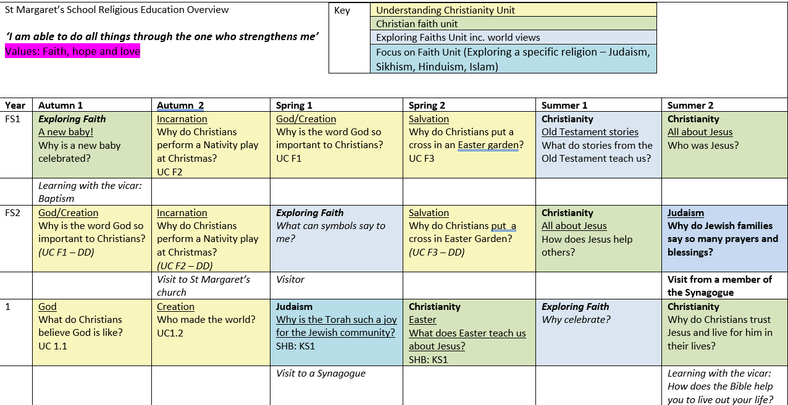
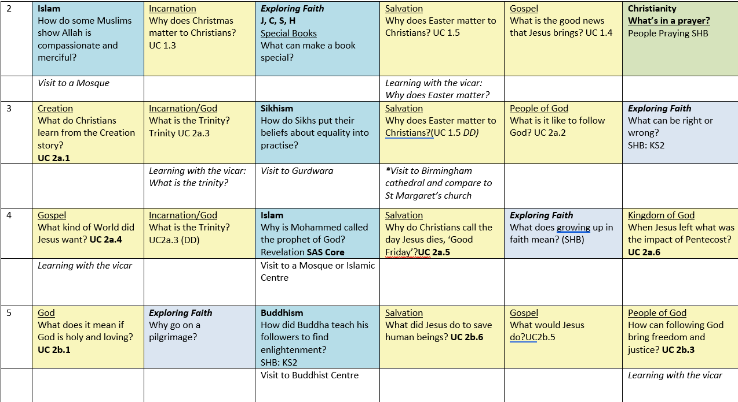
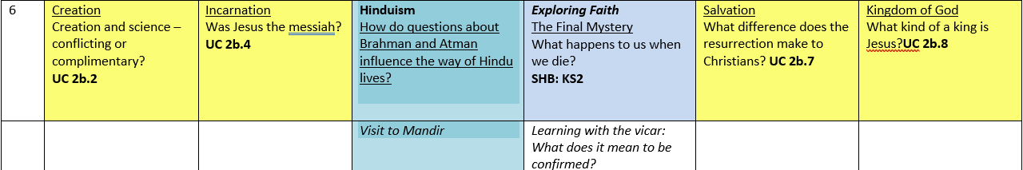

Appendix 2 – Exemplar of unit of work from The Emmanuel Project

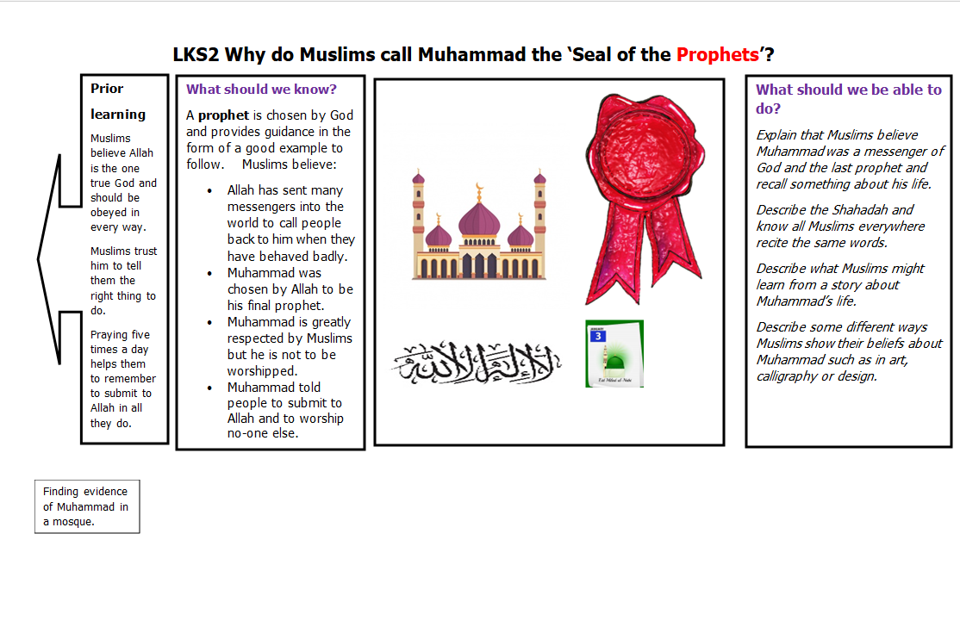
Sample knowledge organiser from ‘The Emmanuel Project’

Appendix 3 – Exemplar of planning from ‘Understanding Christianity’

