

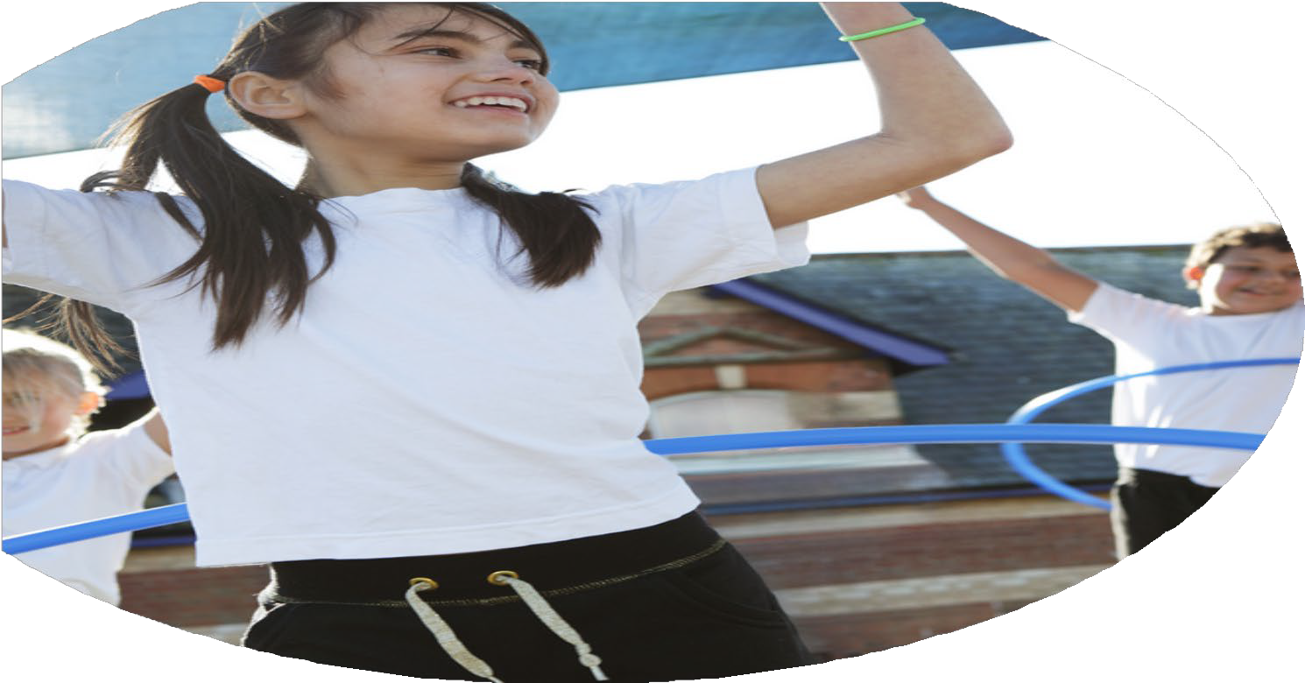
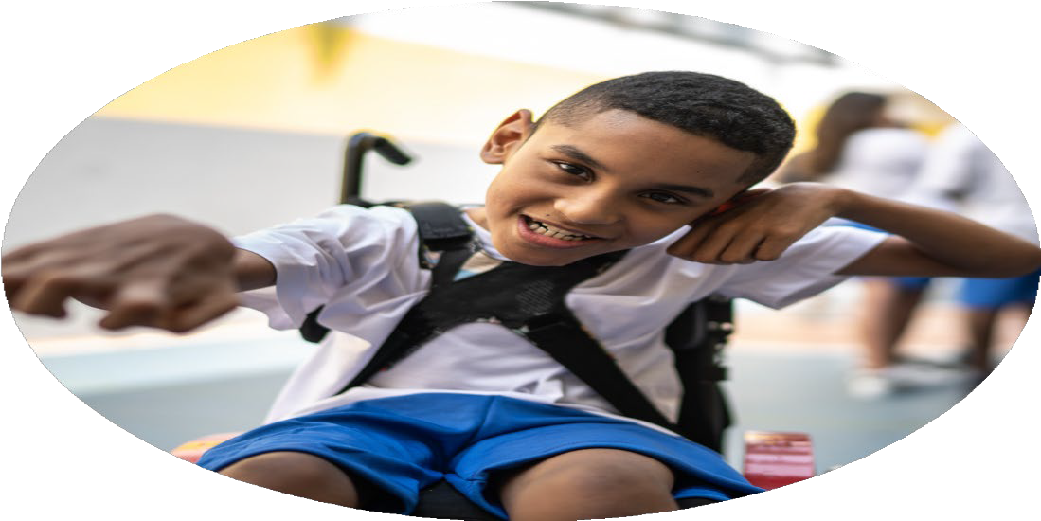




PE Funding

Evaluation Form

Commissioned by

Created by

Images courtesy of Youth Sport Trust

PE Funding Evaluation Form

It is intended that this template should be used as preparation for the completion of the statutory digital reporting tool being introduced this academic year. You can upload data (including swimming) from this template onto this platform once it becomes accessible.
Before you decide how you are going to use the funding for this academic year you should reflect and evaluate the impact of your use of the funding in 2023/24.
All spending of the funding must conform with the terms outlined in the Conditions of Grant document. The template is a working document that you can amend/update during the year.
Based on your evaluation of last year’s funding you should decide what you intend to do this academic year, how you will do it, and what impact you expect it to have.

It is important that the funding is used effectively and based on your school’s needs.
You must use the funding to make additional and sustainable improvements to the PE and sport in your school. You must develop and add to the PESSPA activities that your school already offers.

Summative digital reporting from June 2025 will continue to include swimming and water safety information therefore funding can be used to provide top-up lessons where necessary to ensure pupils meet national curriculum swimming requirements.

We recommend that you start by reflecting on the impact of current provision and reviewing your previous spend

What went well? | How do you know? | What didn’t go well? | How do you know?
Continuing SSP membership and participation in sporting events and staff training.  Lunchtime activities have been developed through an increase in sports coach and pupil led activities using support from Solihull School Partnership  Silver School Games Mark Achieved.  Bronze YST Quality Mark Achieved  CPD for staff so that all teaching is at least good and staff confidence and subject knowledge improves and supports raising pupil attainment  Increase the variety of competitive sports that pupils have the opportunity to partake in.  Increase the extra-curricular offer of sporting activities. | Each child across the school taking part in at least one competition organised through SSP  PE leaders CPD  Guidance and support for all staff available through the membership  An increasing number of pupils are participating in a wider variety of sporting activities at lunchtimes. Pupils are now confident to lead these alongside staff and the sports coach.  The quality of PE lessons has improved with teaching being good in most cases. Staff have been able to identify personal areas for development and had specific coaching within these areas.  Pupils have had access to an increase of competitive sports across key stage 2 including cricket, cross country, athletics, cheer leading, dance, netball, football.  Pupils have had access to an increase of competitive sports across key stage 2 including cricket, cross country, athletics, cheer leading, dance, netball, football, tennis, multi sports. | Ensure that lunchtime supervisors receive training to increase activities on offer.  Did not meet the criteria for Gold in the SGM.  Did not meet the criteria for Silver in YST QM. | SGM – Target for Gold  Targeting Year 6 Pupils to receive partnership coaching and attend the ‘transition to secondary’ event (Solihull Tag Rugby Festival) – Unable to cover travel costs this year due to budget.  YST QM – Target for Silver  Thorough tracking of pupil physical activity levels (daily 60 active minutes) - Using the Sports Coach for a timetabled Intervention for targeted low activity Pupils.

What are your plans for 2024/25? | How are you going to action and achieve these plans?
Intent | Implementation
1.To improve the quality of PE teaching and staff confidence across all key stages.  2. To broaden the range of sports and activities offered to all pupils  3. To develop competitive opportunities for pupils across the school.  4. Increase Physical activity throughout the school day | - Participate in Premier Education CPD programme to give staff the opportunity to observe, collaborate and review teaching practice across the PE curriculum.  - PE lead to observe lessons and provide feedback.  - Use pupil voice to identify areas of interest.  - Provide a range of extra-curricular sporting activities before and after school  - Costs for Travel to SSP Sports events  - Enter sport competitions and leagues through Solihull School Sports Partnership.  - Organise inter-House competitions at the end of each topic.  - House Cup to celebrate interhouse competition  - Use Koboca survey to gain pupil voice on current physical activity levels  - Track travel to school with Living Streets Tracker  - Provide Lunchtime activities through Active Play Heroes and Premier Sports Coaches.  - Provide an after-school club targeting low-activity pupils to try new physical activities.  - Active play lead to increase engagement in physical activity during lunchtime  - Active play equipment to be purchased

What impact/intended impact/sustainability are you  expecting? | How will you know? What evidence do you have or  expect to have?
1.  . Teachers will be more confident to deliver topics across the PE curriculum  2. A broad range of extra-curricular sports and activities offered to all pupils  3.A schedule of competitive opportunities for pupils across the school.  4. Pupils’ Physical activity increased throughout the school day | 1.  . Pupils will show better outcomes in PE lessons  . Observed lessons will meet the objectives more effectively  . Lessons will be more active and engaging  2.  . Pupils will participate in a wide range of sporting and physical activities  . Clubs will be fully subscribed with participants  3.  . Participation in a range of competitive opportunities  . A range of pupils attending sports events  4.  . Active Play Heroes trained and delivering sessions  . Premier Sports Coach and Play Lead engaging pupils in Physical Activity

What impact/sustainability have you seen? | What evidence do you have?
1.  . Staff completed Premier sports CPD programme  2.  . A range of clubs offered both school funded and parent funded to increase participation in physical activity  3.  . A range of sports and physical activity events participated in through the Solihull School Sports Partnership  4.  . Active play heroes have delivered sessions each lunchtime  . Premier Sports Coach and Play Lead engaging pupils in Physical Activity | 1.  . Staff completed CPD Health Checks  . Service Level agreement from Premier Education  . PE Lead observations  2.  . Club timetable  . Club registers  3.  . Booking confirmation on SSP  . Letters to parents with intent  4.  . Active Play Hero timetable  . Certificates for 10, 20 and 30 sessions

